READ ME:

1. Open "C:\Program Files (x86)\HAMILTON\Config\ML_STARType.cfg
2. Copy and paste the contents below in between the last two rows at the bottom of the list:
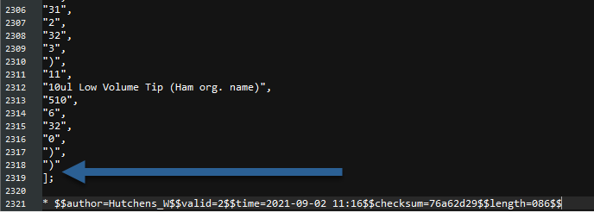
"(70",
"311",
"2",
"53",
"1",
"612",
"0",
"54",
"1",
"65",
"-1",
"514",
"8",
"66",
"0",
"37",
"0",
"58",
"15.8",
"(9",
"30",
"1",
")",
"11",
"PLT_CORE_COVER_A00 (Ham org. name)",
"510",
"0",
"32",
"2",
")",
")"

